Women in the Word March 7, 2023
Acts 18:24 – 19:1 – 20 IMH

INSPIRING Events in Ephesus

INTRODUCTION
A. Map of the Third Missionary Trip
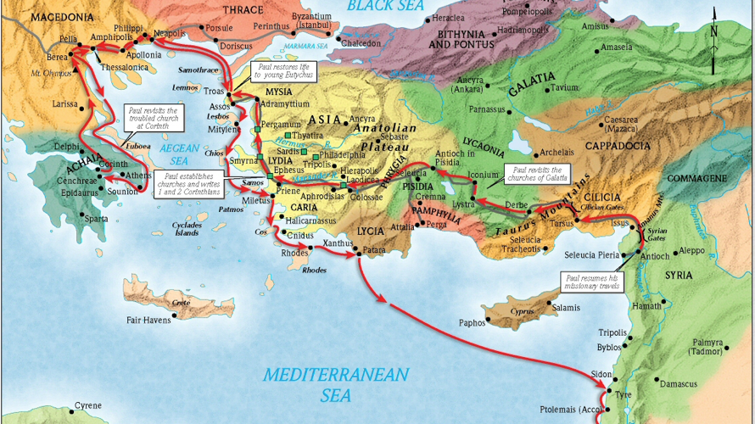

B. The City of Ephesus

C. The Temple of Artemis

I. A man with an INCOMPLETE message
A. Background

B. Influence of Aquila and Priscilla

C. Verses re. Apollos: I Cor. 1:12; 3:4-6, 22; 4:6; 16:12; Titus 3:13
II. Twelve men with an INCONSISTENT witness
A. Paul’s challenge: “Did you receive the Holy Spirit when you
believed?”

B. When Paul laid hands on them, the Holy Spirit falls on them.

Important Question:

III. A school for daily INSTRUCTION
A. Preaching and teaching in the synagogue first

B. Establishing a Bible school

C. Vs. 10: “This went on for two years, so that all the Jews and
Greeks who lived in the province of Asia heard the word of the
Lord.”

IV. Seven men with INADEQUATE power
A. Extraordinary miracles of Paul to show his apostolic authority
(as with the other apostles)
Mark 16:20; Romans 15:18- 19; 2 Cor. 12: 12; Hebrews 2: 1 – 4

B. Handkerchiefs and aprons

C. Counterfeits – the seven sons of Sceva
1. Attempted to cast out spirits in Jesus’ and Paul’s names
2. The demon says, “Who are you?” and attacks the men.

3. Result: God is glorified when the people burn their scrolls
containing their evil spells.
Value
True repentance – To God be the Glory!!!

